## What is data?

Any raw and unprocessed fact that we can record is known as data.

Example - New Delhi, India

In the above example New Delhi, India could be an address of a person or capital of a country but we are unable to analyse anything meaningful from it, hence it is data.

## What is information?

When we process the data to get meaningful facts, it is called information. Example - New Delhi is the capital of India.

Here we are getting some meaningful facts about New Delhi, hence it is information.

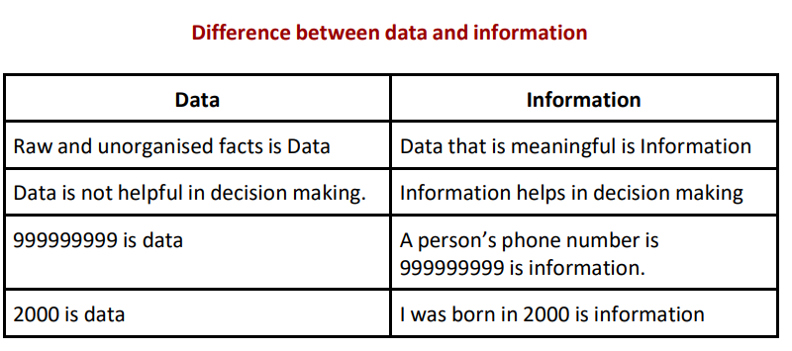

## What is database?

## A Database is a collection of related data organised in a way that data can be easily accessed, managed and updated. Example - Let us consider Facebook. It needs to store, update and show related data of members, activities, messages etc. Here we can use the database to do all these operations efficiently.

## What is database management system?

A Database Management System or DBMS is a system that allows creation, definition and manipulation of databases, allowing usersto store, process and analyse data easily. DBMS provides users with an interface or a tool, to perform various operations like creating a database, storing data in it, updating data, creating tables in the database and a lot more. MySQL, PostgreSQL, Microsoft Access, Oracle, MongoDB, Cassandra etc are all examples of DBMS.

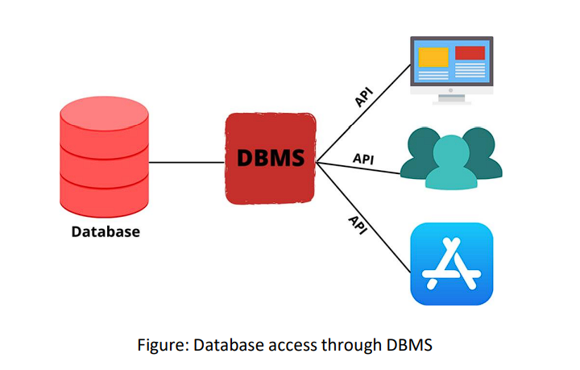

## What are the File Systems?

File System is a way of naming the files and storing them in a storage medium. File Systems helps in organizing the data and allows to retrieve the files easily when needed. Due to the increase in data, the need for File Systems is also increasing. Different file systems are available for different operating systems.

Features of File Systems:

1. Data is stored as isolated data files and entities.

2. It costs less as compared to a database.

**Installation Guide for MY SQL on Windows.**

**Step 1:** Download the MySQL installer from the given link :[Download MySQL Installer](https://dev.mysql.com/downloads/installer/) . There are two download options. One is a web community version(2.3M) which will download only the server and you can add the other applications you want to install on it. The Second one is a Community version(470.2M) which is a full installer and will download the server along with all the recommended applications.

You have to install the community version (470.2M) of My SQL.

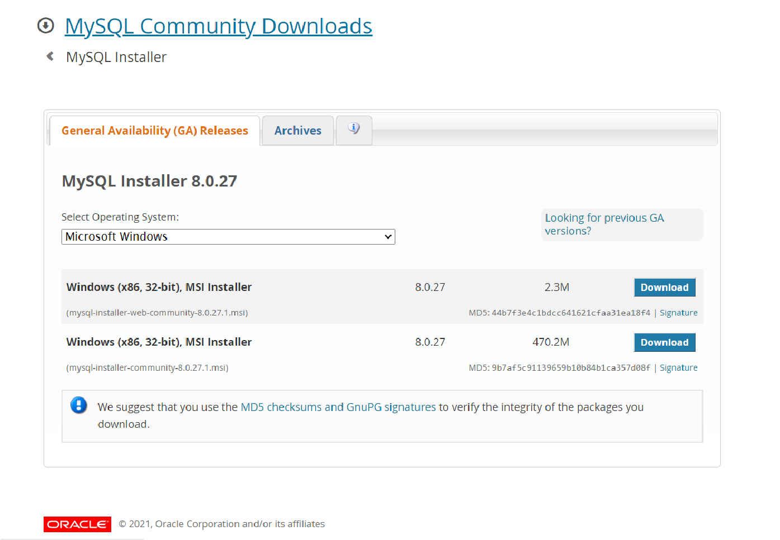

**Step 2:** Click on the download button and it will pop up a page asking to login or signup. but you skip this part by scrolling down to the bottom and clicking **No thanks, just start my download**. After clicking on this, your download will start which will take around 1 min.

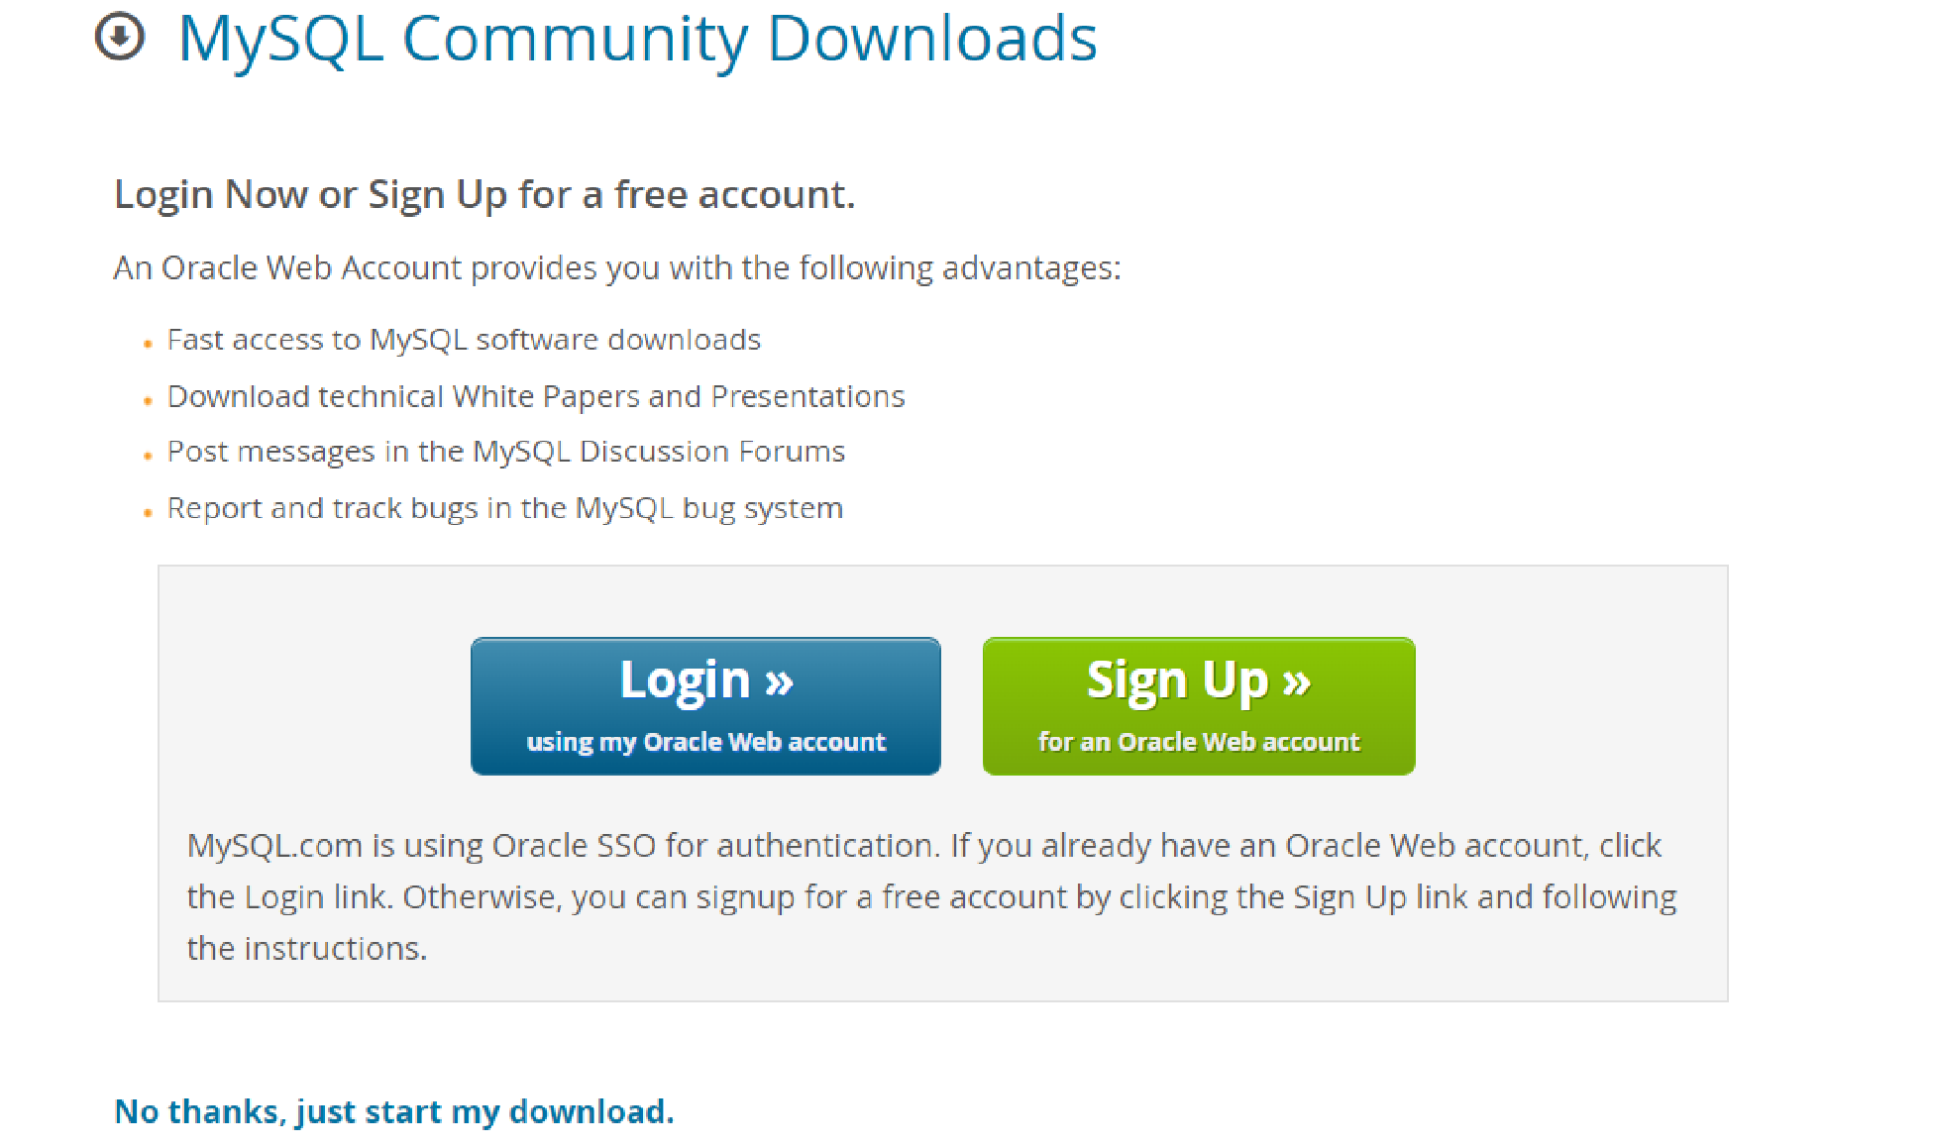

**Step 3**: Run the installer that you have downloaded from its location on your server by right clicking and open or by double clicking.

**Step 4**: The MySQL installer screen will open and you have to determine the MySQL installation type in the Choosing a setup Type section.

There are 5 options given:

**Developer Default:** this is the full installation of MySQL Server and the other tools needed for development.

**Server Only:** if you only need MySQL Server installed for use with a CMS or other application and will not be managing the database directly, you can install just the server

**Client Only**: It will install only the client products of MySQL and will not install the server for running that.

**Full:** It will install all the products and features of MySQL.

**Custom**: this setup type will allow you to customize every part of the installation from the server version to whichever additional tools you select.

You need to Choose **Developer Default** to install MySQL server and other MySQL tools related to MySQL development, helpful tools like MySQL Workbench.

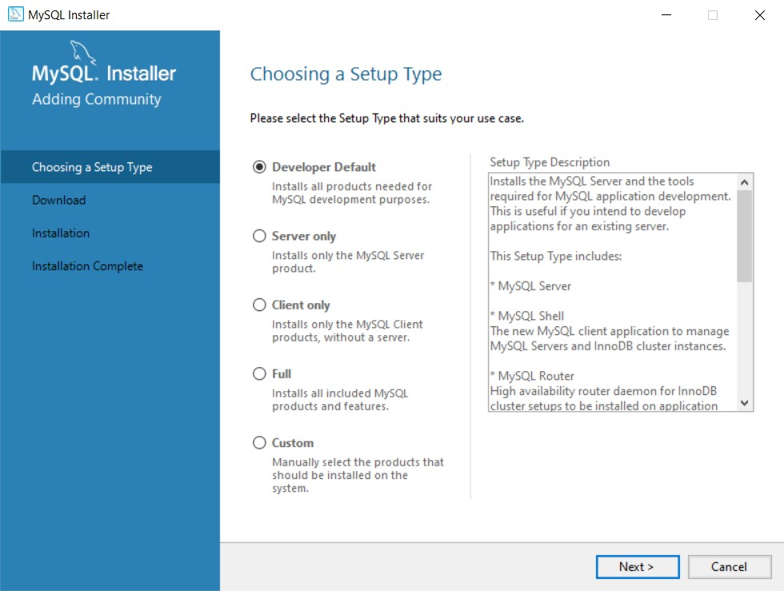

**Step 5:** After you click on Next, A download page will open which consists of all the applications that need to be installed on the MySQL Server. Click on the execute button to start the download.

The download will take some time and you can see the progress of the downloads on the same tab.

**Step 6:** After all the applications get installed, click on the next button which will appear in place of execute after successful installation. Now, a new tab will open which contains other applications, Click on the execute button.

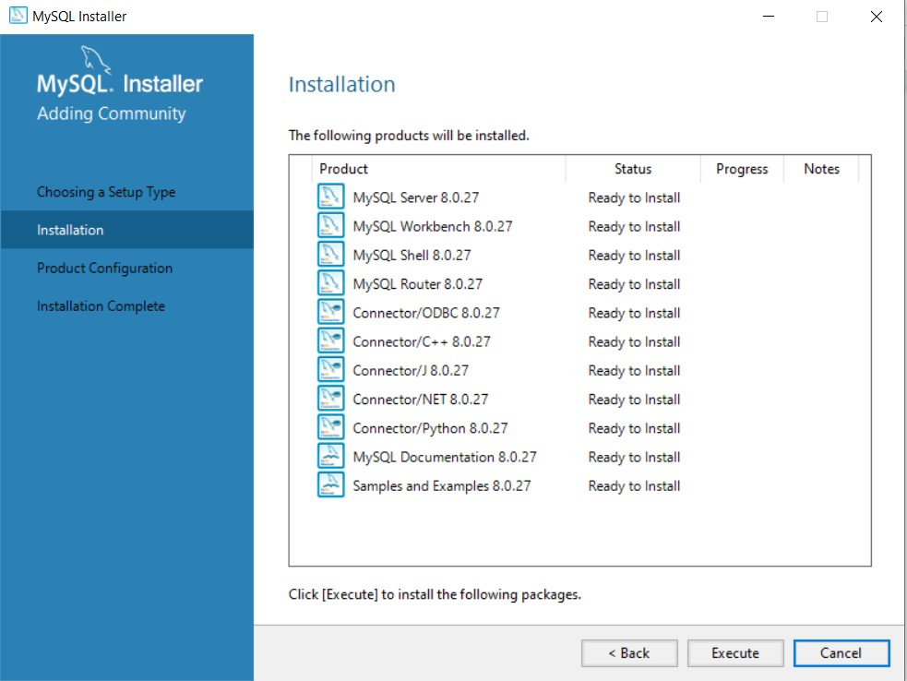

**Step 7:** After all the products are installed, click on the next button. The product configuration page will open. Click on the next button.

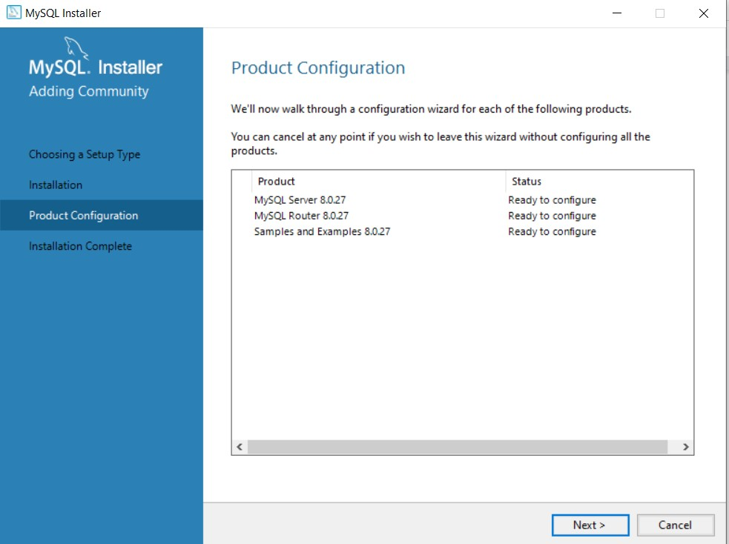

**Step 8:** Now, Keep Clicking on the next button for the given pages until the Accounts and Role Page appear.

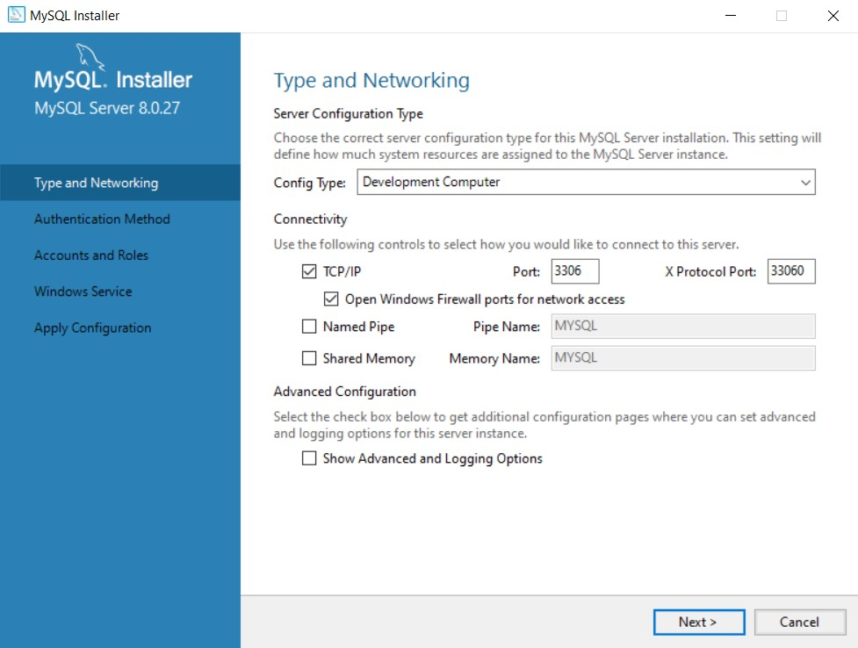

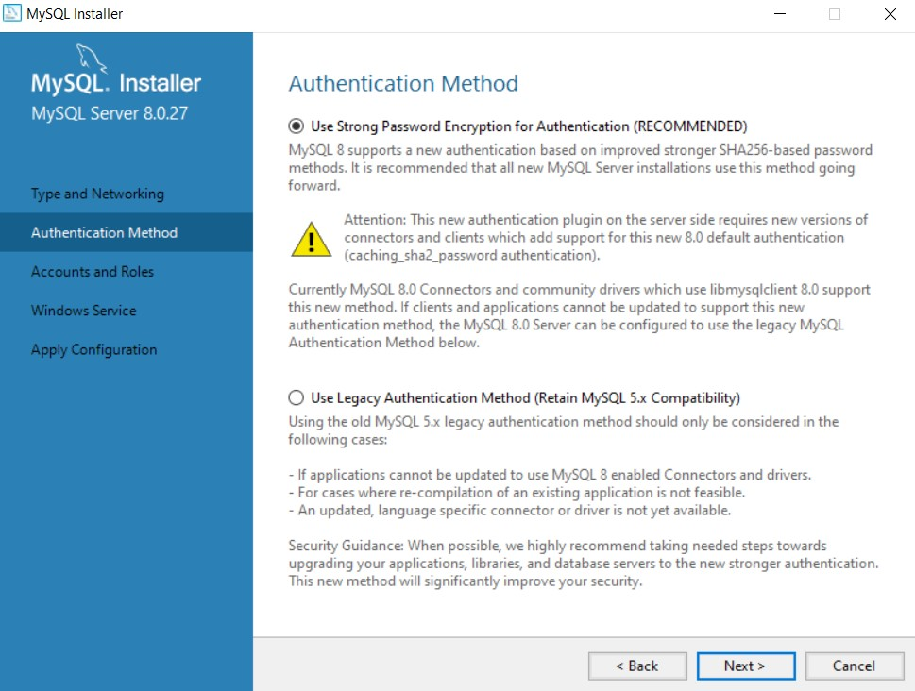



**Step 9**: In the Accounts and Role ,you need to set up a password for your SQL. Set up the

Password. After setting up the password, Click on the next button

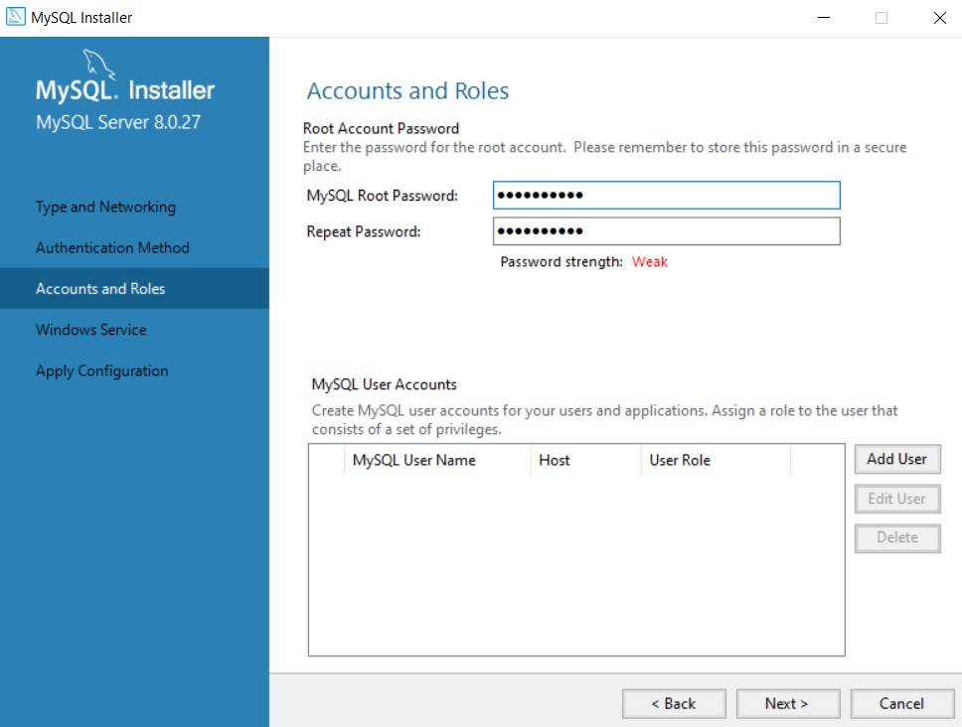

**Step 10**: Click on the next button for the Windows Service page. On the Apply Configuration page, Click on the execute button.After you click execute, it will execute all the configuration Steps and the Finish button will appear at the bottom right corner Click on that.

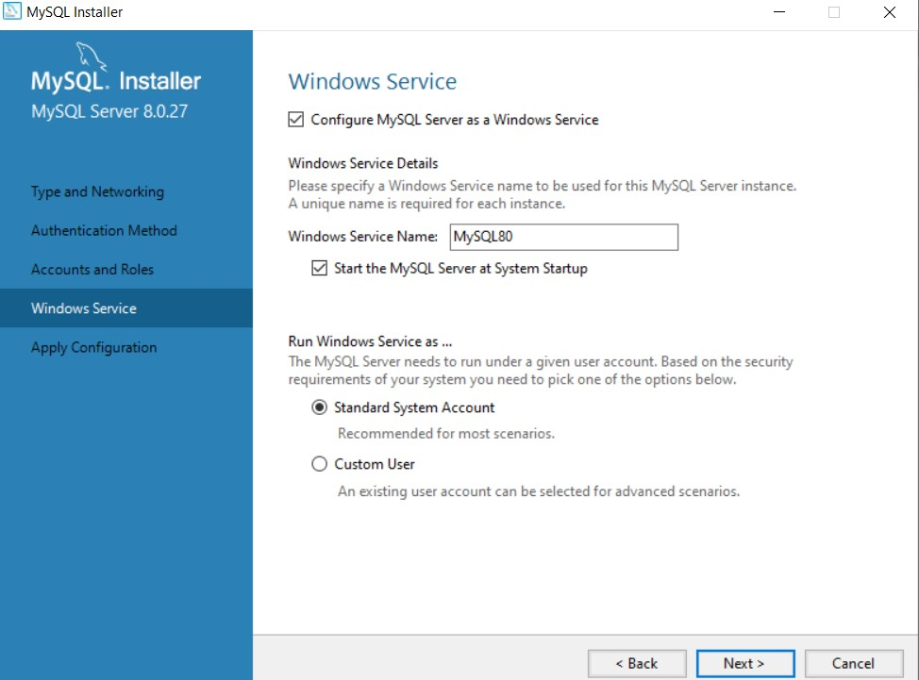

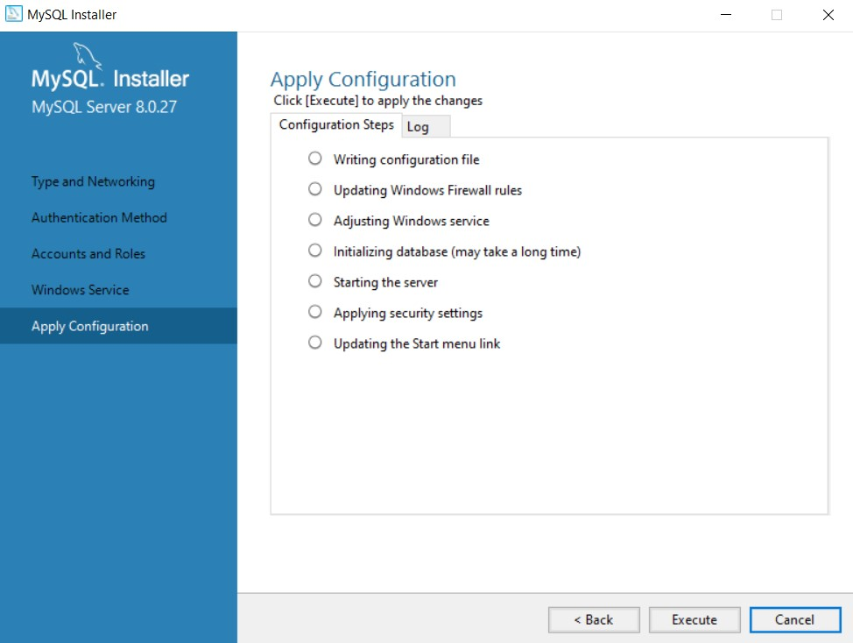

**Step 11**: Click on the Next buttons and after that MySQL router configuration page will appear click on the Finish Button.

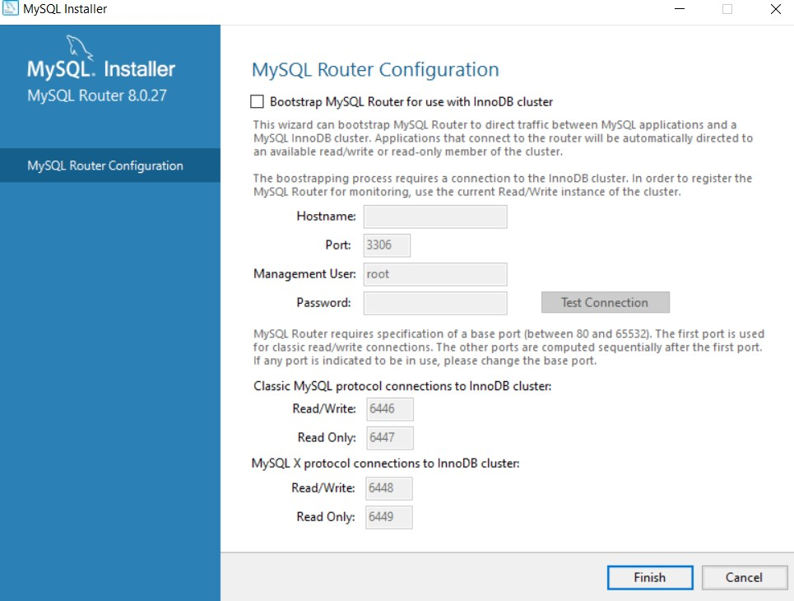

**Step 12:** You will be asked to Connect to Server by entering the password you set up earlier. Enter the password and click on check. You will see Connection Succeeded in Green color which means your connection is successful.

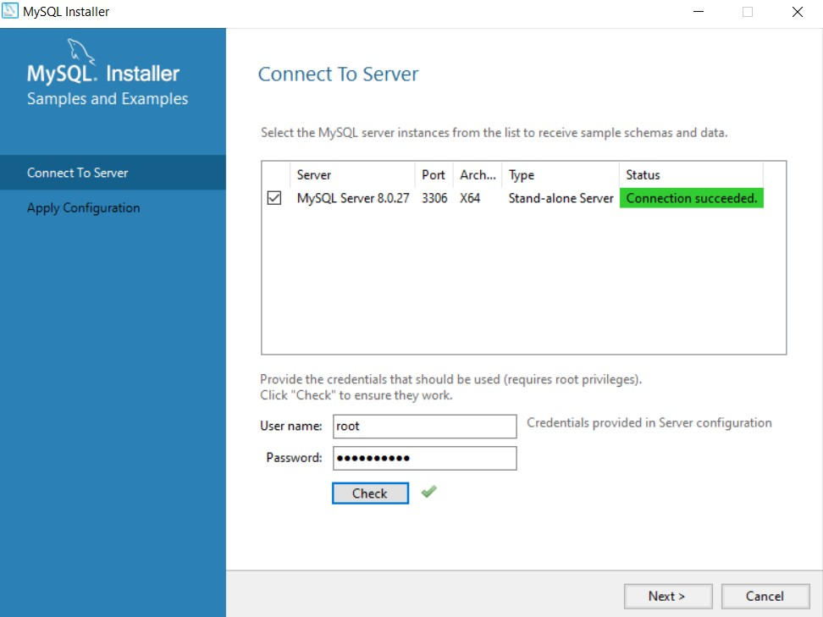

Click Next, and you will reach the Apply Configuration page, Click on execute

**Step 13**: After this the installation Complete page will appear. Click on the Finish Button to complete the installation process.

**You have successfully installed MySQL on your device.**

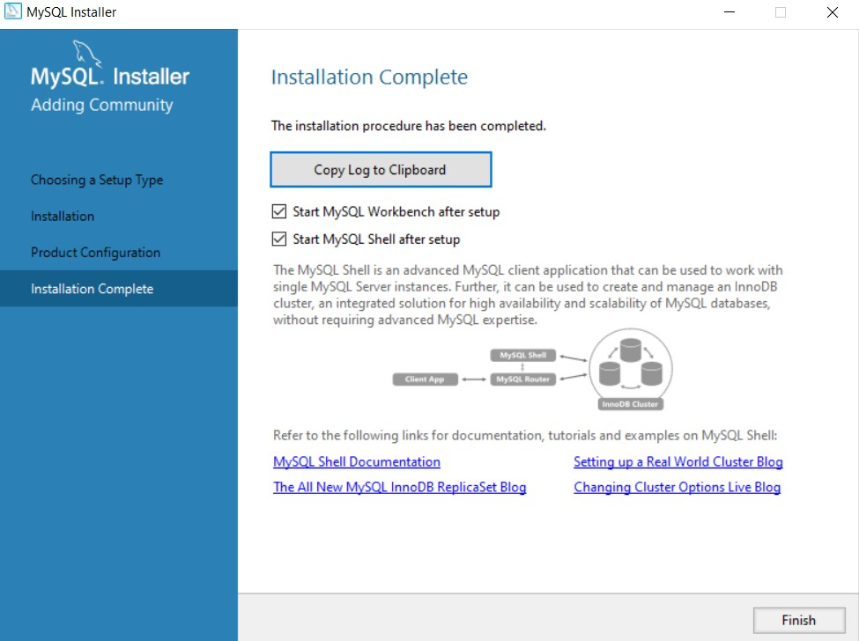

**To use MySQL Shell:**

Search ‘MySQL Shell’ on your system and click on Open.

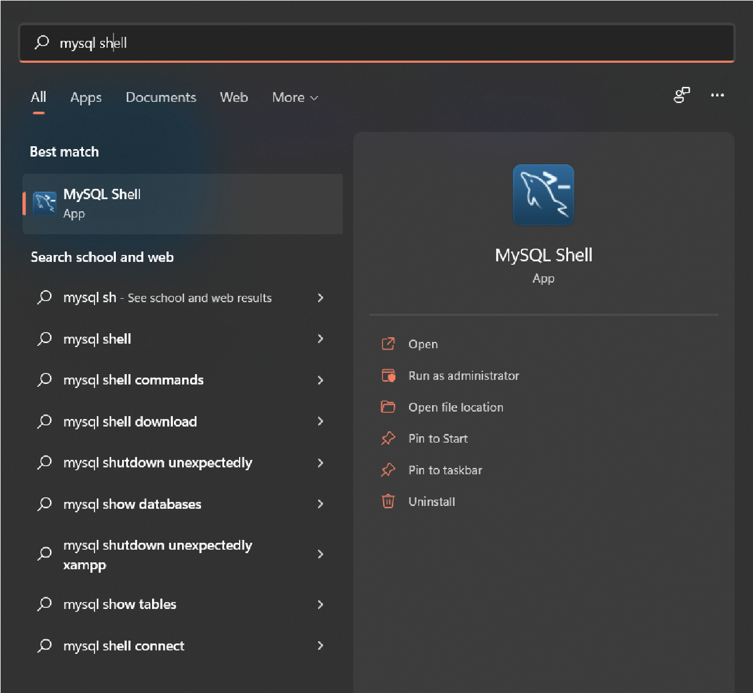

**To use MySQL Workbench:**

Search ‘MySQL Workbench’ on your system and click on Open.

